**A Report**

**On**

**VBE&A ASSIGNMENT-2**

VALIDATION OF TATA INDICA WITH 2-D MANIKIN (10%)

SUBMITTED TO: -

**DR SUSHIL CHANDRA**

**Submitted By**

**Name of the Student**   **Enrolment Number**

GUNDA VENKATA SAI JAI HARSHA 190C2050003/190169

BATTULA SRI RISHITH SATYA SURYA 190C205001/190167

NAMBURI GOWRI MANIKANTA 190C2050008/190174



SCHOOL OF ENGINEERING AND TECHNOLOGY

BML MUNJAL UNIVERSITY GURGAON

**ABSTRACT** **3**

**INTRODUCTION** **4**

**Validation with 2D Manikins** **5**

**Manikin Preparation** **6**

3-D Model 6

**Evaluation of the Tata Indica ECS** **9**

Normal Posture 10

Full acceleration posture 11

Touching the hand to the dashboard 12

**Permissible limits for angle** **13**

**Observation** **13**

**Conclusion** **13**

# 

# 

# 

# 

# 

# ABSTRACT

In this project, we are doing 2-D manikin to validate Tata Indica ecs cars. to validate the car our group took 10% of people’s dimensions from SAE standards. We have prepared the manikin by using cardboard sheets. We have measured the different parameters when the driver is sitting in different postures. After measuring all the parameters, we will compare them with SAE permissible values for the same parameters to validate the car with made 2-D manikin(10%).

# INTRODUCTION

Automotive ergonomics focuses on the role of human factors in the design and use of automobiles. This includes analysis of accommodation of driver and/or passengers; their comfort; vision inside and outside the vehicle; control and display design; pedal behaviour, information processing, cognitive load during driving, etc.  
  
In the present module, an attempt will be made to discuss various physical aspects of occupant packaging for providing comfortable driving posture, clearance dimensions, proper view field, easy reach of the controls, etc. to the driver.  
  
This module highlights the following:  
  
• Spatial accommodation  
   - Seating Position  
   - Leg Room  
• Sitting comfort /discomfort  
• Reach and limitations of human  
  
To establish the required interior space, and arrange the interior and structural components, the design methods rely on the human factors database through years of research and practical applications from SAE standards.  
  
The anthropometry for automotive design is consistent with the driver and passenger safety, comfort, convenience, and accommodation. The study of human capabilities and limitations gives the measurements for designing automobiles.

# Validation with 2D Manikins

In automobile design, at first, the position of the occupant/driver with a comfortable driving posture on the seat is defined. Then all other components are arranged around the driver to provide easy reach, vision, and control operations.  
  
Few reference points e.g. H-point, BOF, AHP, etc. are used as standard practice to define the driver’s position while SRP, NSRP, and SRP are generally used to define the seat position of the driver.  
  
• H-point ( Hip pivot): Midpoint of the line connecting two hip joints.  
• BOF (Ball of Foot): Ball joint of Foot.  
• AHP (Accelerator Heel Point): position of the heel while placed on the accelerator.  
• SRP (Seat Reference Point): Intersection point between the midline of the compressed seat back and compressed seat pan.  
• NSRP (Neutral Seat Reference Point): 50th percentile person selected SRP.  
• SRP: 10th percentile person selected SRP.  
  
These landmarks (below shown figure) relate the occupant to components in the vehicle interior such as foot controls, seat, and floor. For example, the foot is related to the ball of the foot and accelerator heel point, whereas the hip, hand elbow, and shoulder width are related to the h-point location.  
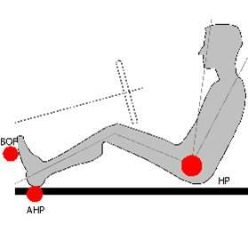  
**Landmarks for measurements.**

# Manikin Preparation

First, we have taken the dimensions of SAEJ628 to be 10%.

Then Bi-dimensional manikin from SAE J826 is recommended practice for interior packaging. Only the dimensions related to the leg (ankle-knee distance A), and knee-hip distance B) are related to the percentile, the others are fixed. The foot and the trunk are of fixed size. This choice is motivated by the need to ensure a minimum allowance to the trunk and the foot, even if this could generate rather absurd situations when the leg size is that of small percentiles (5th or even 50th). The four elements of the manikin are hinged together. All dimensions are expressed in mm.

Then we made a 2d sketch by using A, B,C, D

After making the 2d sketch we have taken cardboard and made a 2d model of the manikin by using the dimensions of all a,b,c, and d cut the board according to the shape and dimension, and all fixed by nut and bolt.

## 3-D Model

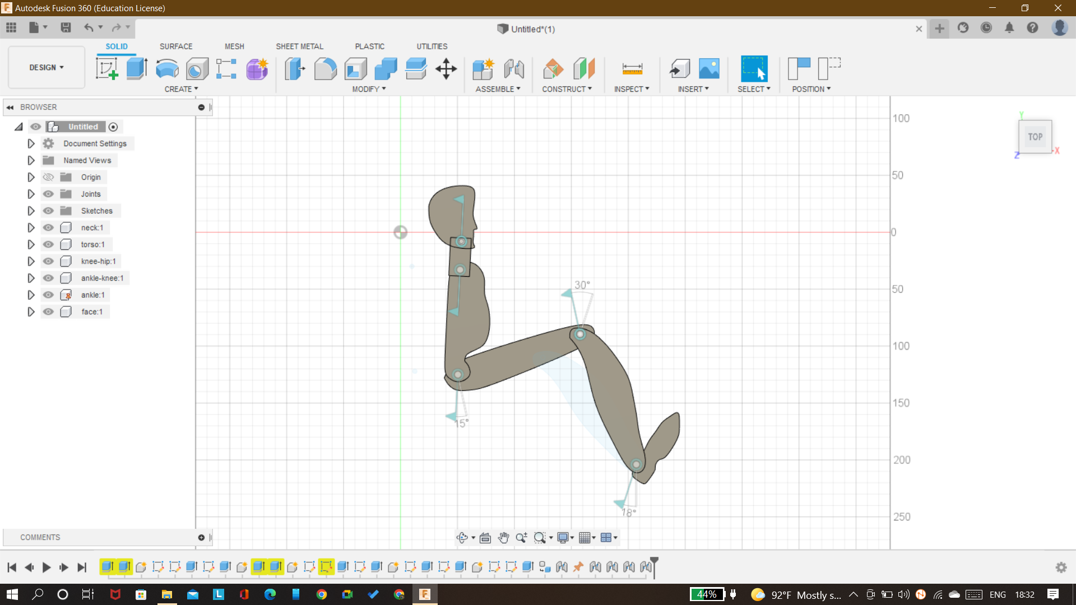

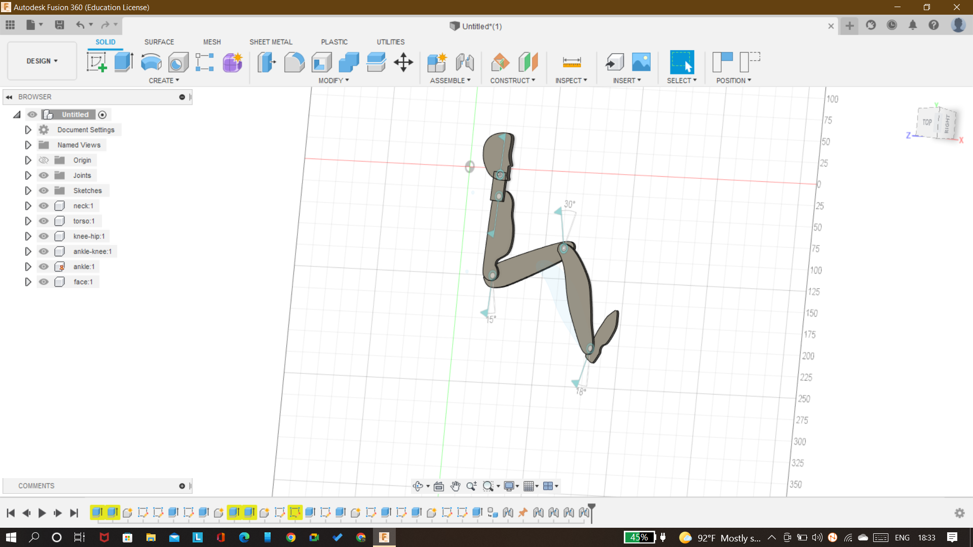

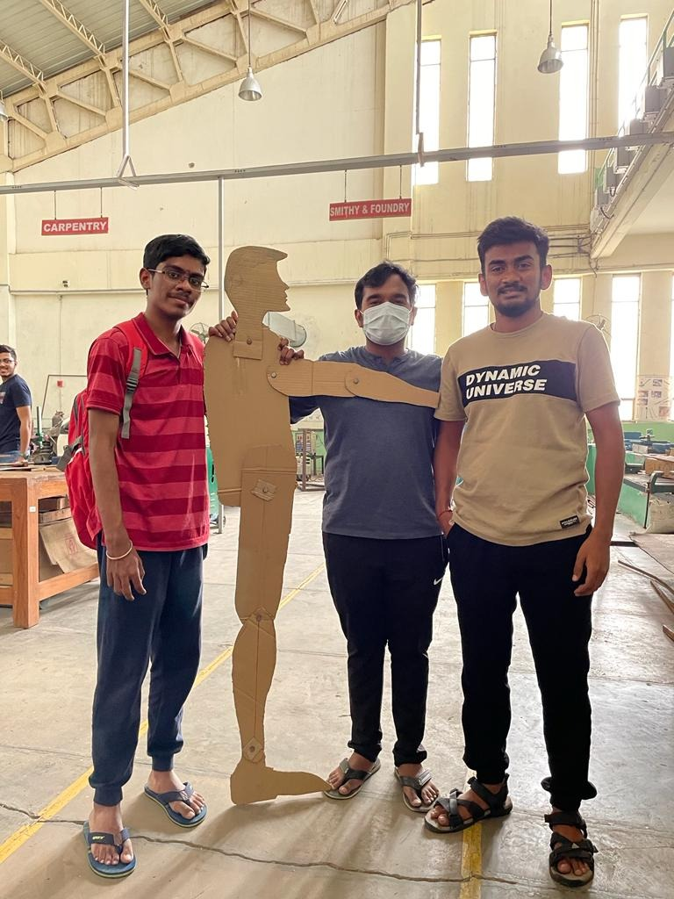.

We have fitted all the cut parts with nuts and bolts so that they will act as rotating joints and we are able to change the angles between the parts.

After setting it in the car we measured all dimensions which are relative to the driver's position with the car interior as shown in the following images.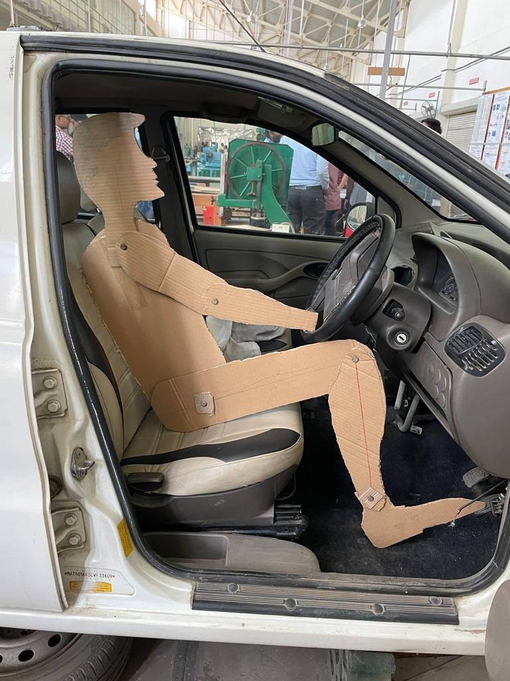

# 

# 

# 

# Evaluation of the Tata Indica ECS

for these following postures, we have measured the all the parameters which are required to validate the 2d manikin

1 Normal Posture

2 Full acceleration posture

3 Touching the hand to the dashboard.

## Normal Posture

The angles of normal posture are mentioned in the 2d sketch and these angles are measured by using taper angle measuring as in the car.



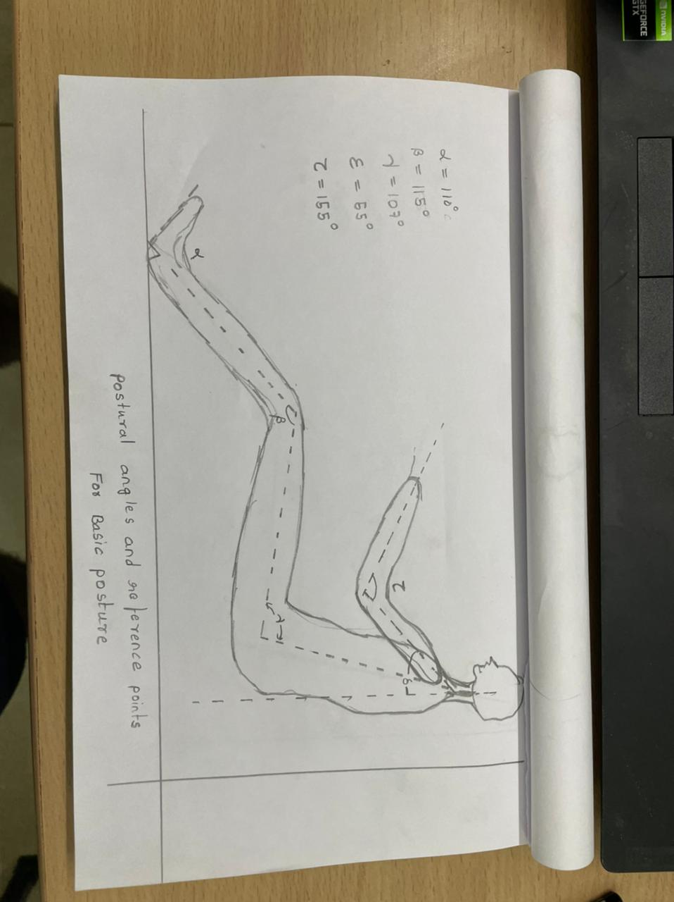

## Full acceleration posture

Here we measured all the parameters when the accelerator pedal is completely pressed. as shown in the following figure the manikin is fitted.

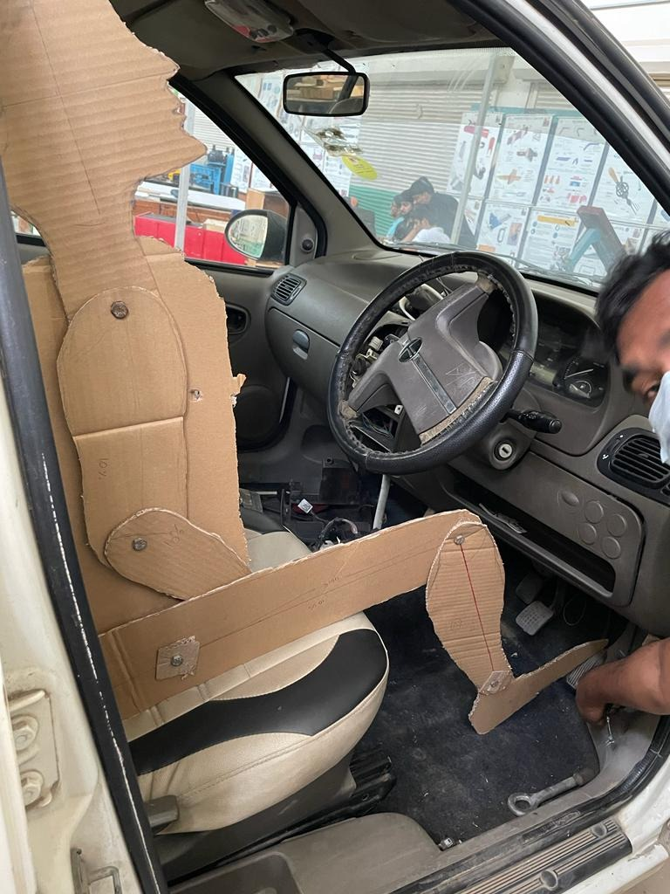

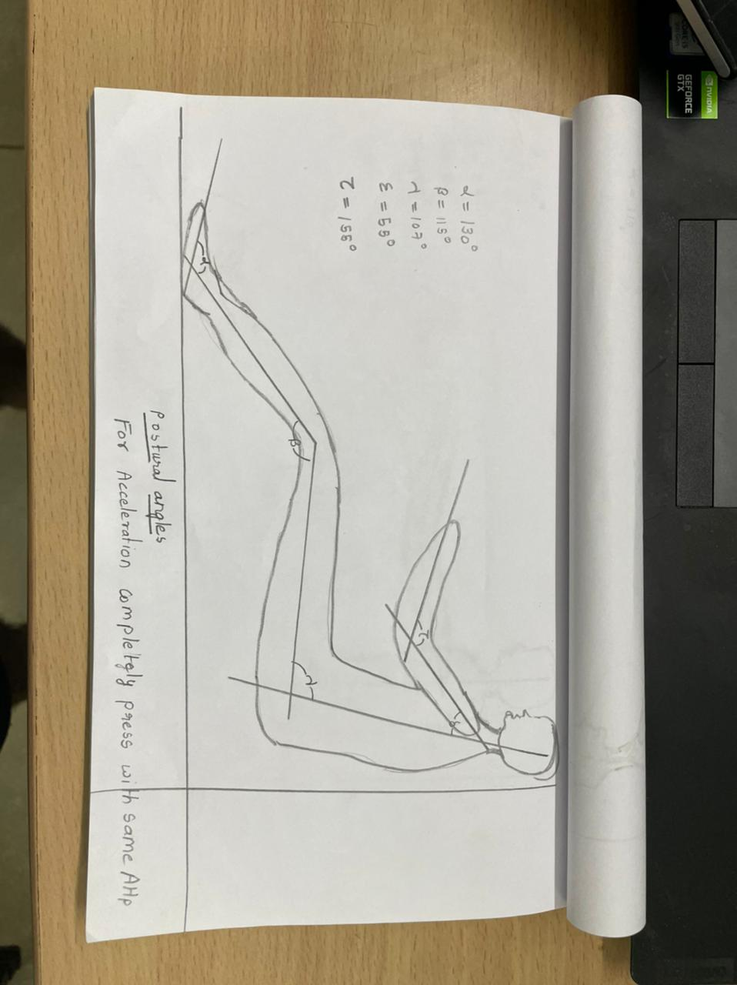

## Touching the hand to the dashboard

This is the posture where the driver is trying to operate something on the dashboard. So he lifts his torso to get up to the dashboard.

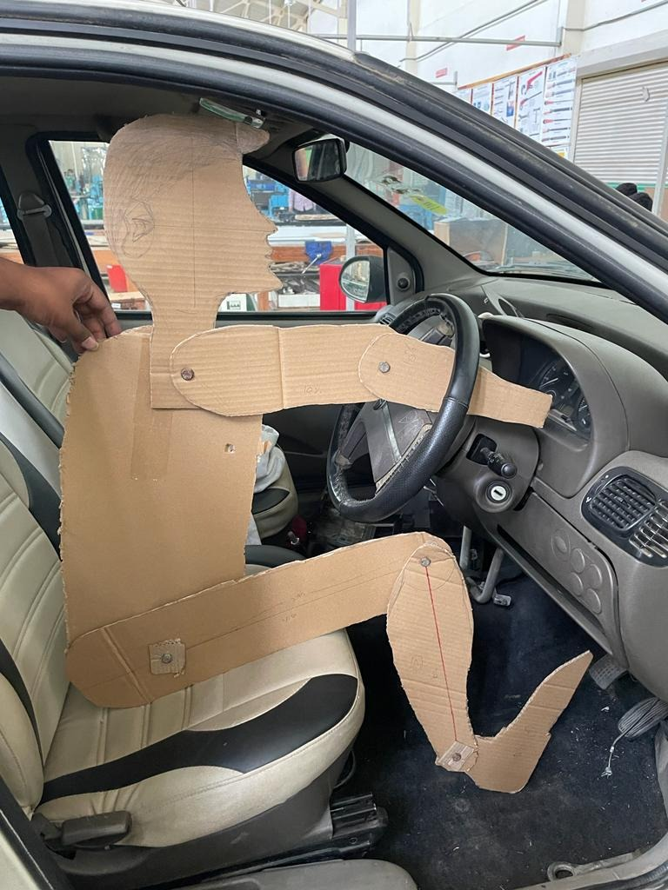

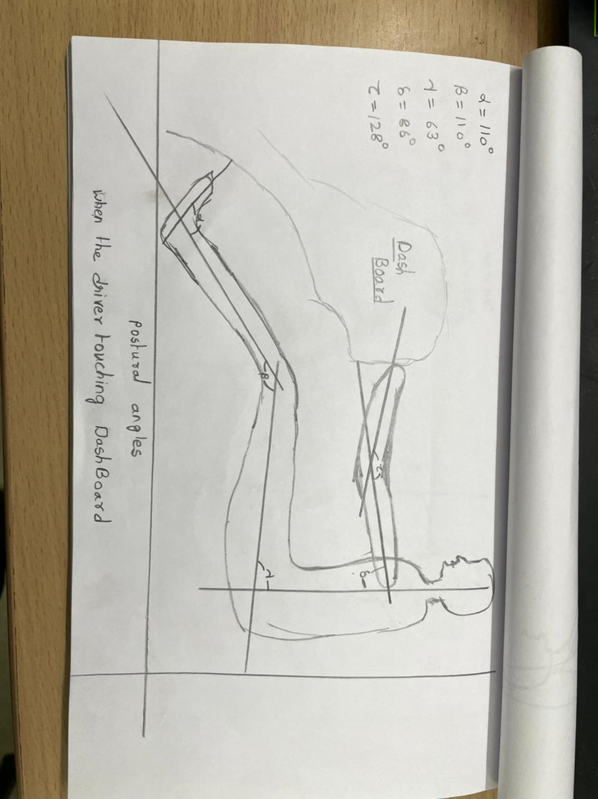

# Permissible limits for angle

For more comfort and less effort by joints, we should make sure that at any time and in all postures all Angles (degrees) allowed by the main joints in the lateral plane *xz* of the vehicle should be in the permissible limits which are shown in the following image.

# 

# Observation

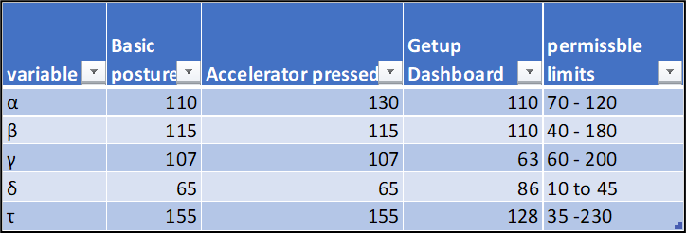

# Conclusion

When we observe the results we can tell that in all the postures which we tested all the angles are within the permissible limits so that there will not be any high effort by any joint, more pressure on the Lumbar segment of the backbone, uncomfortness. So we can validate that 10% of the people use TATA Indica ECS cars with all comforts.